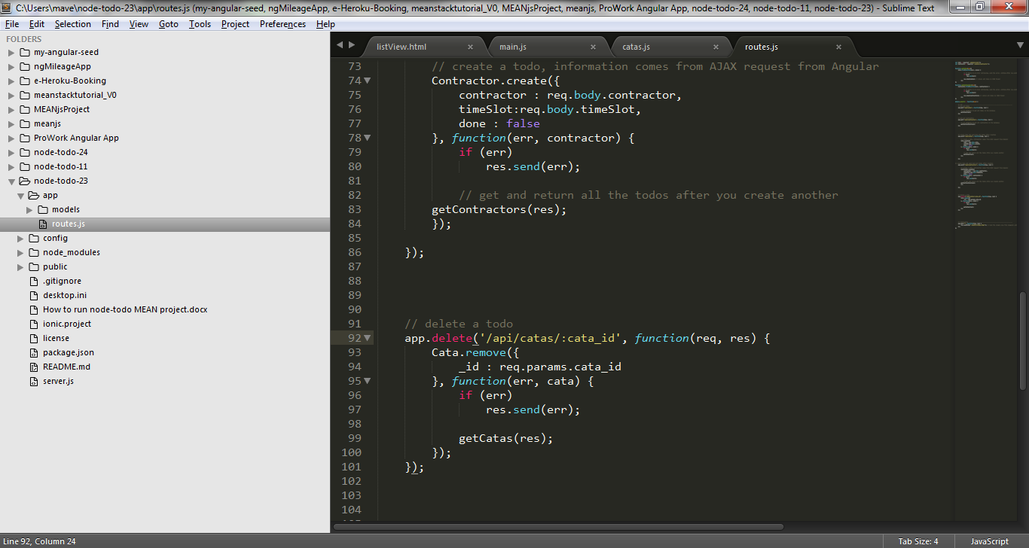

Attention please: req.params.cata_id must match /api/catas/:cata_id